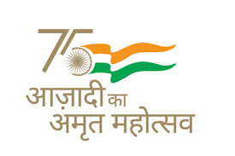
Kendriya Vidyalaya Sangathan (HQ)

New Delhi
Extension Notice for Admission: 2022-23

The last date for Online Registration for Admission to Class I in Kendriya Vidyalayas for the Academic Year 2022-23 has been extended upto 11.04.2022 (Monday) 07:00 pm. Accordingly, the Online Registration, which has commenced on 28.02.2022, will now close at 07:00 pm on 11.04.2022. The other contents of the said admission notice 2022-23 will remain unchanged.

